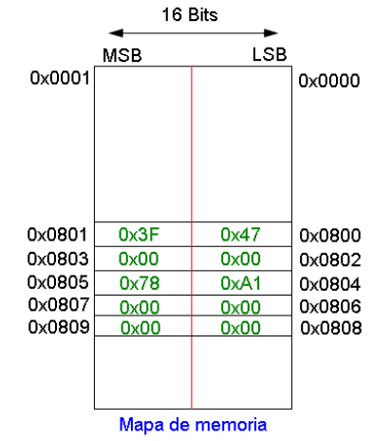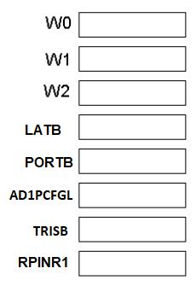

1. Input mapping. This is the value of the register for attaching the external interrupt 2 to RP11/RB11
2. The output of W0



1. Configure PORTB as:

<1,3,5,7,9,B> OUTPUTS

<0,2,4,6,8,A> INPUTS

INT0 attached to <E>

INT1 attached to <F>

1. What is the Time of the following instruction using a 20MHz Oscillator?

ol